The Islamia University of Bahawalpur
Department of Information Technology
Faculty of Computing


SOFTWARE DESIGN DOCUMENT (SDD)
for
Smart Attendance Tracker With QR Codes
Version 1.0

By
Student Name: Zeeshan Ahmad Virk
Roll No: S23BINFT1M01115
Session: Spring 2023 – 2027
Supervisor: Ms Sara Fareed
Bachelor of Science in Information Technology

Revision History

Date | Description | Author | Comments

Document Approval
The following Software Design Document (SDD) has been accepted and approved by the following:
Signature |  | Printed Name | Title | Date
 | .

Supervised by
Ms Sara Fareed
Signature______ _____

INTRODUCTION

Advent

the subsequent subsections of the software program requirements specifications (SDD) record ought to provide a outline of the entire SDD..

1.2 Motive
Our purpose in this project is to develop a system that could capture attendance efficiently, accurately, and automatically by means of QR codes. This aims to eliminate errors that can occur with manual methods of capturing attendance, save paper and reduce processing time to facilitate the administrator, teachers and staff of educational institutions to be more productive.

1.3) Target audience
.This attendance system is suitable for use in schools, colleges and universities, as well as corporate offices, and has been designed with administrators, teachers, HR departments, and office staff in mind. In addition, students and employees will appreciate the ease and speed at which they can scan a QR code to record their attendance.

1.4) Scope
We are developing a web based solution for easy attendance tracking and management using QR (Quick Response) Codes built using PHP and MySQL. Easy to use interface, allows administrator to view, edit and monitor attendance details. It can be extended with features such as Mobile App for attendance tracking, SMS/Email notifications for administrators, attendance reports and much more. This saves a lot of time for administrators and also makes a organization’s management systems more accurate and efficient.

2.SYSTEM ARCHITECTURE

2.1 Architectural Design
The system's design is a web-based client-server solution utilizing PHP and a database with a web-based front end and back end. This configuration allows for easy scalability and maintainability using a split front end / back end approach. The system incorporates both QR code generation and QR code reading functions and seamlessly interfaces all system parts together. This configuration allows for the robust, flexible, and reliable handling of attendance data.

2.1.1 User Interface (UI) and User Experience (UX)
The system has a simple, clean & User Friendly interface both for Admins & Users. The system has an easy to use interface with obvious navigation to Mark Attendance and View Reports etc. It’s super fast and supports QR Code Scanning using smartphone cameras. The system is designed to minimize the users’ efforts & makes it accessible for students, faculties & admin.

2.1.2 Backend Architecture
This module for school, college or university management is completely developed with PHP script and configured to fetch and update data through internet to validate school generated QR codes for tracking students attendance and processing the attendance data for generation of reports. The system is designed to handle any number of users at same time without compromising on the robustness and stability of system. It also manages to process data accurately.

2.1.3 Security
Our system is built with robust Security Features such as user authentication, secure login, and encryption of data. It also has an Access Control feature that ensures the correct people have access to viewing and editing attendance to the system data.

2.1.4 Search and Filtering
The system includes a feature rich search and filter system allowing attendance records to be efficiently searched and filtered by admins to find relevant attendance records. Using the intuitive filters attendance records can be sorted by date, user name and attendance status. Using these filters makes it easier for admins to find the attendance information required allowing relevant reports to be generated and attendance patterns analyzed efficiently.

2.1.5 Overall Performance
The system is designed with speed in mind in handling attendance records. QR code scanning is quick and simple to use. The backend system can handle simultaneous requests for long periods of time. The system has been further performance optimised for faster page loading and data retrieval.
2.2) Decomposition Description

User Management Module
The Users module contains all system participants including students, employees and administrators. In this module users can be added, updated, deleted, with each user receiving their own unique QR code. This module also manages users’ roles, permissions to work with different system modules and other settings that allow users to have different access rights to work with various functions and ensure overall system control.

QR Code Generation Module
This module will generate unique QR Codes for each registered user. Those generated QR codes will be used to mark attendance in a faster and accurate manner. These generated QR Codes will be secure and will not be easily duplicated. This will help to make attendance marking process faster and reduces manual involvement and errors.

Attendance Management Module
Attendance tracker records attendance information by scanning of QR codes. Records all scanned QR codes along with date, time and user information. All records can be viewed and edited by the admin for accurate attendance tracking and recording. Helps in recording and tracking attendance in real time and accurately and provides efficient management of attendance.

Authentication and Authorization Module
Login system to securely recognise user. Role based access controls for admin and normal users. Only logged in users with the correct permission can edit attendance or generate reports for data privacy, system security and against unauthorised access.

Database Management Module
This module handles the functionality for storing, managing and retrieving the systems data (system, users and attendance). This includes maintaining data integrity and usability. The database module can handle large amounts of data and is also able to support creating backups and performing a recovery in the event of data loss.

Dashboard Module
The Attendance Management module comes with a module-wide dashboard that visually displays various summary statistics related to the attendance and attendance tracking activities. This includes summary of attendance records for employees as well as other related statistics such as records marked as present or absent, details of last login, tracking attempts, timed out attempts and number of records approved or rejected. The module dashboard also displays summary statistics for employee attendance and login activities such as details of last login, tracking attempts, timed out attempts, approved and rejected attendance records to facilitate quicker administrative decision making.

Search and Filtering Module
The software includes a fully searchable attendance module to enable you to search for specific attendance records using a variety of search filters. By searching by date, name or attendance status, the attendance module makes administration much more efficient by saving time when searching for individual records as well as allowing administrators to easily analyse attendance records for reporting and monitoring purposes.

Report Generation Module
You can generate as many attendance reports as you like. The reports can be sorted by Date or User and can contain data for any time frame you wish. The Attendance Reports module to the Attendance extension provides WordPress website administrators the ability to view official attendance numbers and get in depth details on attendance statistics. Reports can also be exported for further reference.

2.3) Format cause

2.3 User Interface and User Experience Requirements

2.3.1 Visual Design
The system has a simple, clean & User Friendly interface both for Admins & Users. The system has an easy to use interface with obvious navigation to Mark Attendance and View Reports etc. It’s super fast and supports QR Code Scanning using smartphone cameras. The system is designed to minimize the users’ efforts & makes it accessible for students, faculties & admin.

2.3.4 Security
Our system is built with robust Security Features such as user authentication, secure login, and encryption of data. It also has an Access Control feature that ensures the correct people have access to viewing and editing attendance to the system data.

2.3.5 Performance
The system is designed with speed in mind in handling attendance records. QR code scanning is quick and simple to use. The backend system can handle simultaneous requests for long periods of time. The system has been further performance optimised for faster page loading and data retrieval.

2.3.6 Search and Filtering
The system includes a feature rich search and filter system allowing attendance records to be efficiently searched and filtered by admins to find relevant attendance records. Using the intuitive filters attendance records can be sorted by date, user name and attendance status. Using these filters makes it easier for admins to find the attendance information required allowing relevant reports to be generated and attendance patterns analyzed efficiently.

2.3.7 Integration with Third-Party Tools
The system's design is a web-based client-server solution utilizing PHP and a database with a web-based front end and back end. This configuration allows for easy scalability and maintainability using a split front end / back end approach. The system incorporates both QR code generation and QR code reading functions and seamlessly interfaces all system parts together. This configuration allows for the robust, flexible, and reliable handling of attendance data.

Class diagram
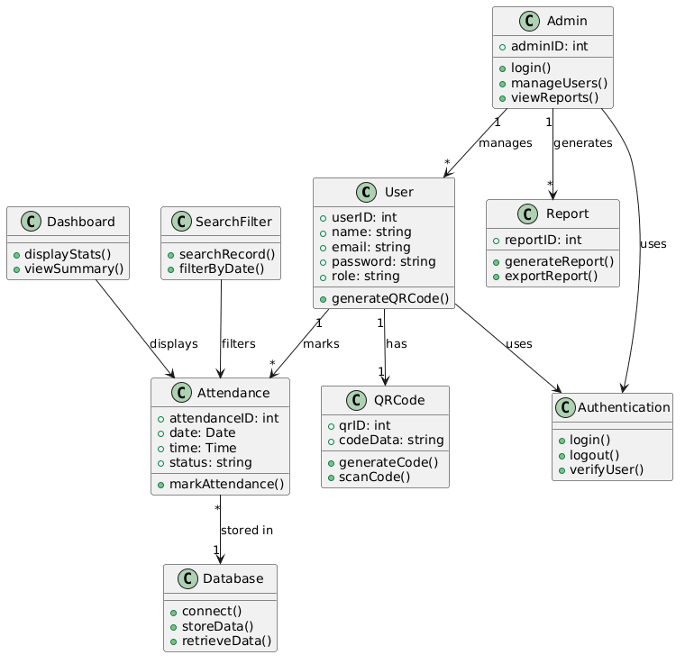
Class Diagram of the QR Code Attendance System, illustrating the object-oriented structure, class attributes, methods, and the relationships between system modules.

Activity diagram
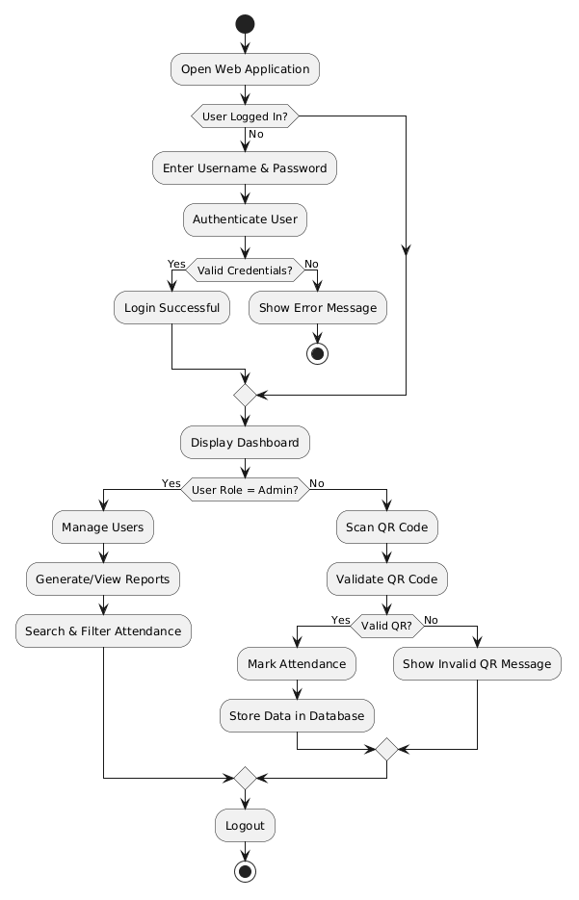
Activity Diagram for the QR Code Attendance System, detailing the operational workflow from user authentication and role-based dashboard access to the execution of specific tasks such as administrative reporting and attendance scanning.

Data flow diagram (0 level)
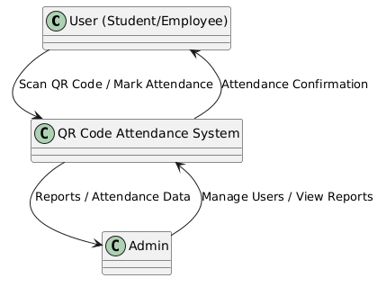
Data Flow Diagram (Level 0) of the QR Code Attendance System, illustrating the high-level data exchange between the system and the external entities (User and Admin).

ER-diagram
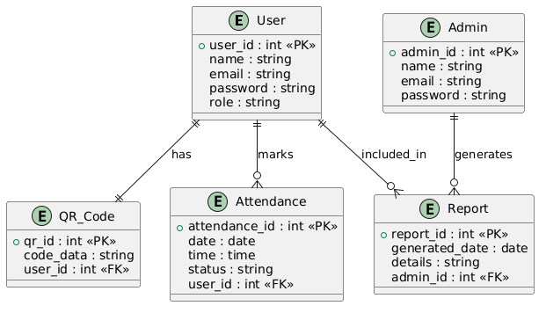
Entity-Relationship Diagram (ERD) for the QR Code Attendance System, defining the database schema, primary and foreign key constraints, and the logical relationships between User, Admin, Attendance, QR Code, and Report entities.

3.DATA DESIGN

3.2)Data Dictionary
Data Element | Type | Format / Size | Description
user_id | Integer | 4 bytes | Unique identifier for each user (student/employee) in the system.
user_name | String | 100 chars | Name of the user registered in the attendance system.
email | String | 100 chars | Email address used for login and communication.
password | String | 255 chars | Encrypted password for secure authentication.
role | String | 20 chars | Defines user role such as Admin or User.
qr_id | Integer | 4 bytes | Unique identifier for each generated QR code.
qr_code_data | String | Variable | Encoded data stored in the QR code for user identification.
attendance_id | Integer | 4 bytes | Unique identifier for each attendance record.
attendance_date | DateTime | ISO 8601 | Date when attendance is marked.
attendance_time | DateTime | ISO 8601 | Time at which attendance is recorded.
status | String | 20 chars | Attendance status such as Present, Absent, or Late.
admin_id | Integer | 4 bytes | Unique identifier for system administrator.
report_id | Integer | 4 bytes | Unique identifier for generated attendance reports.
report_type | String | 50 chars | Type of report (e.g., daily, monthly, user-wise).
report_content | JSON / String | Variable | Detailed report data including attendance records and summaries.
timestamp | DateTime | ISO 8601 | Time when attendance or system activity is recorded.
login_activity_id | Integer | 4 bytes | Unique identifier for user login activity.
alert_type | String | 50 chars | Type of alert (e.g., invalid QR, unauthorized access attempt).

4.HUMAN INTERFACE DESIGN

4.1 Overview of User Interface
We have made as much as possible simple and user-friendly for administrators and users alike. The online interface runs from your web browser - no software installation required. The layout uses clear menus, buttons and links.
Login Page, to prevent any unwanted usage of the system by restricting unauthorized users to login to the system. Dashboard contains summary of user’s attendance records, latest activities updates and few quick actions that can be performed. This dashboard is completely responsive and can be accessed from desktop, tablet as well as mobile version.

Screen Images
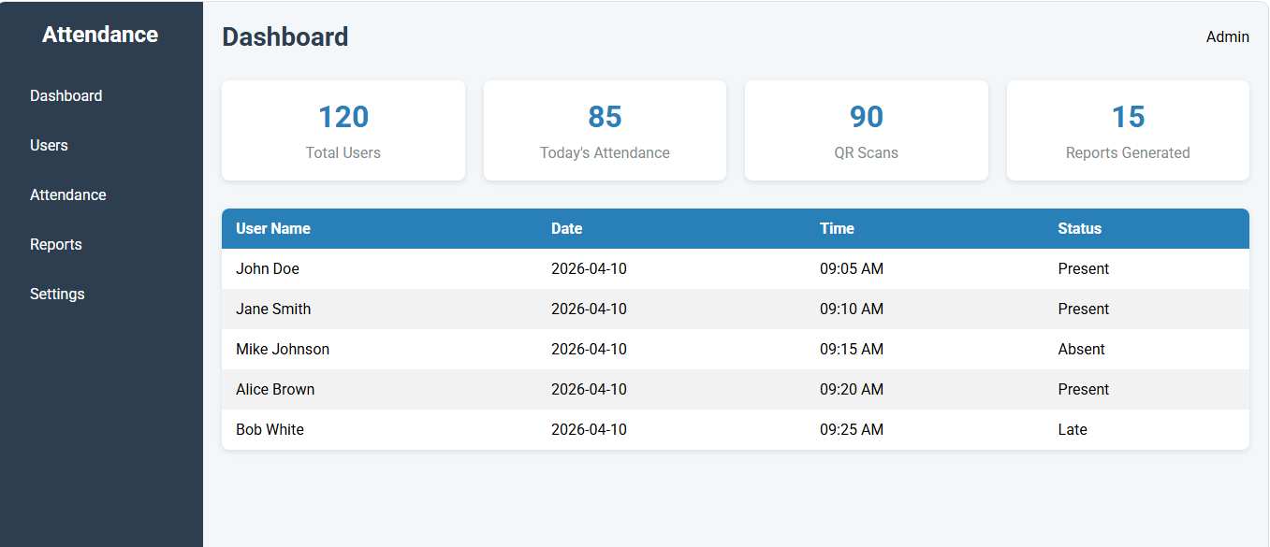

The design will be contemporary to this website

5. REQUIREMENTS MATRIX
Req. ID | Requirement Description | Type | Priority | Module/Feature | Verification Method
FR-1 | System shall allow users (students/employees) to register, login, and manage their accounts. | Functional | High | User Management | Test user registration, login/logout, and profile updates
FR-2 | System shall generate and assign unique QR codes to each user for attendance marking. | Functional | High | QR Code Management | Verify QR codes are unique and properly associated with users
FR-3 | System shall record attendance automatically when users scan QR codes. | Functional | High | Attendance Management | Scan QR codes and verify correct attendance entry in the database
FR-4 | System shall allow admins to view, edit, and manage attendance records. | Functional | High | Attendance Management | Test viewing, editing, and updating attendance records
FR-5 | System shall generate attendance reports for users and time periods as required. | Functional | High | Report Generation | Generate reports and verify data accuracy and formatting
FR-6 | System shall store all user, QR code, and attendance data securely in a database. | Functional | High | Database Management | Check data storage, retrieval, and consistency
FR-7 | System shall allow admins to search and filter attendance records by date, user, or status. | Functional | Medium | Search and Filtering | Test search and filter functionality for different criteria
FR-8 | System shall send alerts for invalid QR scans or unauthorized access attempts. | Functional | High | Notification / Alerts | Simulate invalid scans or unauthorized login attempts and verify alerts
NFR-1 | System shall provide a responsive UI suitable for desktops, tablets, and mobile devices. | Non-Functional | High | User Interface | Test interface on various screen sizes and devices
NFR-2 | System shall load dashboards and process attendance data efficiently (<2 seconds per operation). | Non-Functional | High | Performance | Measure dashboard refresh and attendance data processing time
NFR-3 | System shall ensure secure login, encrypted passwords, and protection of attendance data. | Non-Functional | High | Security | Verify login security, password storage, and data encryption
NFR-4 | System shall be scalable to support multiple users marking attendance simultaneously. | Non-Functional | Medium | Backend / Attendance Management | Test multiple users scanning QR codes at the same time
NFR-5 | System shall maintain logs of user activities, QR scans, and system events for auditing. | Non-Functional | Medium | Logging / Data Management | Review log files for completeness, accuracy, and integrity
NFR-6 | System shall integrate securely with external systems if needed for reporting or analytics. | Non-Functional | Low | Integration | Test secure data exchange with external analytics or reporting tools

